**PROBLEM STATEMENT**

This program will calculate a Fibonacci sequence given the number of terms from the user.

**Output Display**

Fibonacci Sequence Program  
-----------------------------------------------------------------------------

Please enter the number of terms: 20

Fibonacci sequence for 20 terms:

1 1 2 3 5

8 13 21 34 55

89 144 233 377 610

987 1597 2584 4181 6765

**Structure Chart**

Main

Fibonacci

Flowchart for Main

Start

Fibonacci(counter)

for (counter=1; counter < n+1; counter++)

While n <= 0 || n > 40

Prompt user and ask for number of terms (n)

Start

Pseudo Code for Main

Start of algorithm for Main

1. Prompt user and ask for number of terms

- While(n <= 0 || n > 40)  
- Invalid input  
- cin >> n

1. For (counter = 1; counter < n + 1; counter++)  
   - fibonacci(counter);

End of algorithm for Main

Flowchart for Fibonacci

Start

Pseudo Code for Fibonacci

If (n == 0 || n == 1)

End

Return n

Return (fibonacci(n-1) + Fibonacci(n-2))

else

Start of algorithm for Factorial

1. If (n == 0 || n == 1)

- return n

1. Else  
   - return (fibonacci(n - 1) + fibonacci(n – 2));

End of algorithm for Factorial

**Input**

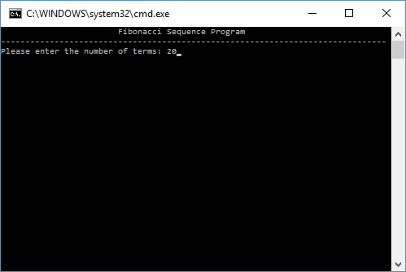

**Output**

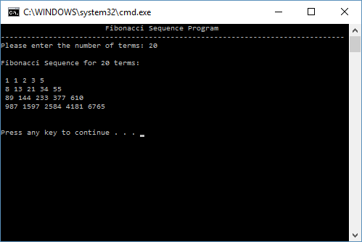

**User Instructions**

This program requires very little input from the user. The program will prompt the user and ask the user to please enter the number of terms in the Fibonacci sequence. Simply enter a number between 1 and 40 and the program will calculate and display a Fibonacci sequence with the number of terms you entered.

**Comment**

Figuring out how to implement the Fibonacci sequence using a recursive function was a bit tricky for me I must admit. I definitely need more practice with recursive functions to get a feel for how they work because they do still feel a bit foreign to me. I’m sure with enough practice in the future I will get them down, but I have enjoyed this two part lab and look forward to using everything I have learned this semester in to the final upcoming lab!